**Python**

**Create Notes For Dhruvin**

**👉 Write a comment :**

**( 1 ). Single Line Comment 🡪 # comment**

**( 2 ). Malte Line Comment 🡪**

**‘’’ comment ‘’’**

**( ‘’’ 🡺 Three time single quests )**

**👉 Easy Malte line write comment :**

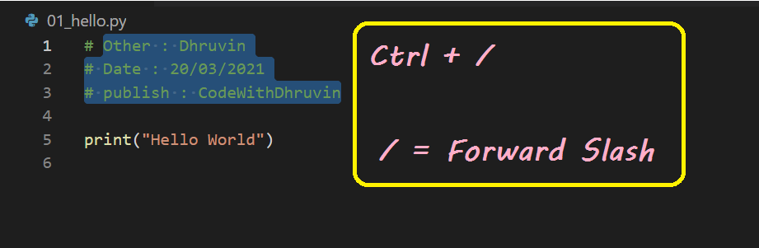

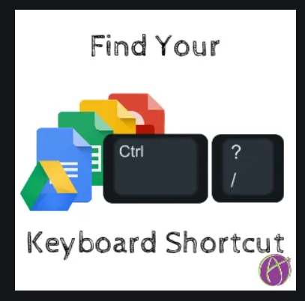

**👉 Keywords :**

The following identifiers are used as reserved words, or keywords of the language, and cannot be used as ordinary identifiers.

🡪 They must be spelled exactly as written here:

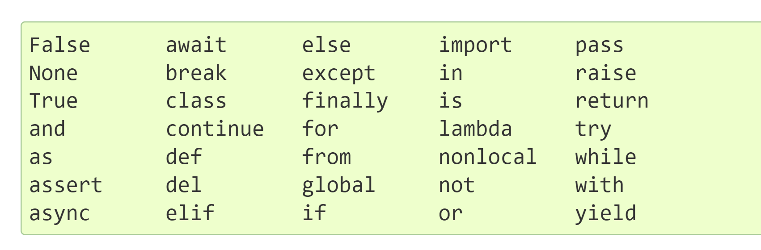

**👉 Data Types :**

There are following data types in python :

(1). Integers 🡪 Ex : 122 , 1021 , 123

(2). Floating point numbers 🡪 Ex : 1.2 , 4.5

(3). Strings 🡪 Ex : “ Dhruvin ” , ‘ Dhruvin ’

(4). Booleans 🡪 Ex : True , False

(5). None 🡪 Denoted by not any value .

**📌 Example : ( Nots of above 👆 )**

* **a = 71 :**

Automatically Identifies a as class < int >

* **b = 88.44 :**

Automatically Identifies a as class < float >

* **name = “ Dhruvin “ :**

Automatically Identifies a as class

< string >

**👉 Operators :**

(1). Arithmetic operators 🡪 (+ , - , * , / ,%)

(2). Assignment operators 🡪

( = ,+= , -= , *= , /= , %= )

(3). Comparison operators 🡪

( == , > , < , <= , => , != )

(4). Logical operators 🡪 ( and , or , not )

**👉 type( ) function and typecasting :**

🡪 This function is easy understood

**VS Code** in Program name is **03_typecasting.py .**

**📌 Example of converting data type :**

* str( 31 ) 🡪 “ 31 “

🡺 Integer to String Conversion

* int( “ 32 ”) 🡪 32

🡺 String to Integer Conversion

* float( 32) 🡪 32.0

🡺 Integer to Float Conversion

Here ,

“ 31 ” is called a string and 31 is called a int .

**👉 input( ) function :**

This function allows the user to take input from the keyboard as a string .

a = input ( “ Enter your name : “)

If a is “ dhruvin “ , the user entered dhruvin.

🡪 Important note , If a is “ 51 ” , the user entered 51 But 51 called a string can not integer value .

**📌** Easy understand this topic in **VS Code** , Program name **04_input_function.py .**

**👉 Lists and Tuples :**

* **Lists :**

List in assign value of any data type .

🡪 Only use a single int data type. (Bellow)

**a = [1, 2, 3, 51, 251, 8]**

🡪 Access using index using a[0], a[1], a[2]…

**Print(a[3]) --------------------- Output : 51**

**🡪List in value is can be change . M.M.IMP**

**a[2] = 10 ----- Output : [1, 2, 10, 51, 251, 8]**

🡪 We can create a list with items of different types .

🡪Other words, Different data type use in list.

**b = [45, “Dhruvin”, True, 6.9]**

* 45 = is a integer datatype
* Dhruvin = is a string datatype
* True = is a Boolean datatype
* 6.9 =is a float datatype

**📌 List Slicing :**

🡪 Index is always start zero (0) .

🡪 But, Minus(-) in index start is always minus 1 (-1). // And count right to lefts side.

Ex: print(name[-4:]) in case -4 to last position print .

**👉 Lists Methods :**

**L1 = [ 1, 8, 7, 2, 21, 15 ]**

**(1). L1.sort() :**

Sorting the list.

**(2). L1.reverse() :**

Reverse the list .

**(3). L1.append(any_number) : M.M Useful**

Add the any_number at the end of the list.

**(4).L1.insert(index , insert_number) :**

Insert_number at bracket in insert index.

**(5). L1.pop(index) :**

Remove element at index.

**(6).L1.remove(remove_number) :**

Remove_number from the list .

🡪 But, Remove number use only list in any number.

**Notes : 👆 L1 is a name . L1 ni jagyaye koy pan name use kari shakay chhe .**

**🡪L1 is one type of identifier name.**

🡺Upar na list method vadhare use thay tevi chhe .

🡺More learn list method click on the link.

<https://docs.python.org/3/tutorial/datastructures.html>

🡺All Python materials in this link online.

<https://docs.python.org/3/>

* **Tuples :**

**🡪 Tuple in value is can not be change . M.M.IMP**

* a = ( ) ---------🡪 Empty tuple
* a = (1, ) ---------🡪 Tuple with only one need a comma
* a = (1, 5, 8, 3) -----------🡪 Tuple with more than one element

**Notes :**

🡺 Tuple Methods :

This topic is follow in VS Code in program is **21_tuples_methods.py** .